EXERCISE 7: PACKAGES
Scenario 1: Customer Management Package
Question:
Create a package CustomerManagement that contains:
- A procedure AddCustomer to add a new customer.
- A function GetBalance to retrieve the balance of a customer.
Package Specification
CREATE OR REPLACE PACKAGE CustomerManagement AS

PROCEDURE AddCustomer(
p_id NUMBER,
p_name VARCHAR2,
p_dob DATE,
p_balance NUMBER
);

FUNCTION GetBalance(
p_id NUMBER
) RETURN NUMBER;

END CustomerManagement;
/
Package Body
CREATE OR REPLACE PACKAGE BODY CustomerManagement AS

PROCEDURE AddCustomer(
p_id NUMBER,
p_name VARCHAR2,
p_dob DATE,
p_balance NUMBER
)
IS
BEGIN
INSERT INTO Customers
VALUES(
p_id,
p_name,
p_dob,
p_balance,
SYSDATE,
NULL
);
END AddCustomer;

FUNCTION GetBalance(
p_id NUMBER
)
RETURN NUMBER
IS
v_balance NUMBER;
BEGIN
SELECT Balance
INTO v_balance
FROM Customers
WHERE CustomerID = p_id;

RETURN v_balance;
END GetBalance;

END CustomerManagement;
/
Execution
BEGIN
CustomerManagement.AddCustomer(
7,
'Kiran',
DATE '2002-02-15',
18000
);
END;
/

SELECT CustomerManagement.GetBalance(7)
AS Balance
FROM DUAL;

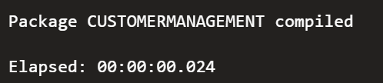
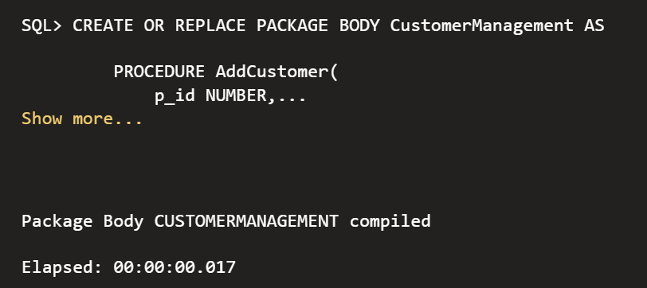
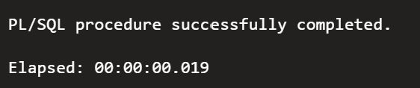
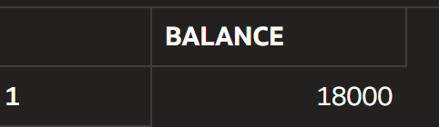

Scenario 2: Employee Management Package
Question:
Create a package EmployeeManagement that contains:
- A procedure to hire a new employee.
- A procedure to update an employee's salary.
Package Specification
CREATE OR REPLACE PACKAGE EmployeeManagement AS

PROCEDURE HireEmployee(
p_id NUMBER,
p_name VARCHAR2,
p_position VARCHAR2,
p_salary NUMBER,
p_department VARCHAR2,
p_hiredate DATE
);

PROCEDURE UpdateEmployeeSalary(
p_id NUMBER,
p_salary NUMBER
);

END EmployeeManagement;
/
Package Body
CREATE OR REPLACE PACKAGE BODY EmployeeManagement AS

PROCEDURE HireEmployee(
p_id NUMBER,
p_name VARCHAR2,
p_position VARCHAR2,
p_salary NUMBER,
p_department VARCHAR2,
p_hiredate DATE
)
IS
BEGIN
INSERT INTO Employees
VALUES(
p_id,
p_name,
p_position,
p_salary,
p_department,
p_hiredate
);
END HireEmployee;

PROCEDURE UpdateEmployeeSalary(
p_id NUMBER,
p_salary NUMBER
)
IS
BEGIN
UPDATE Employees
SET Salary = p_salary
WHERE EmployeeID = p_id;
END UpdateEmployeeSalary;

END EmployeeManagement;
/
Execution
BEGIN
EmployeeManagement.HireEmployee(
7,
'Rahul',
'Developer',
65000,
'IT',
SYSDATE
);

EmployeeManagement.UpdateEmployeeSalary(
7,
70000
);
END;
/
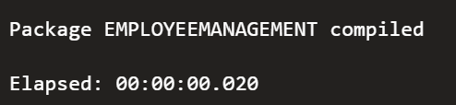
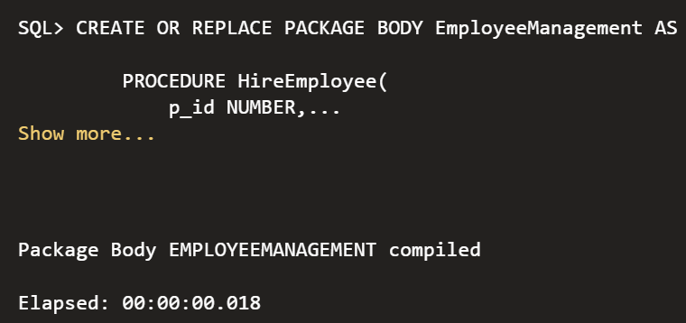
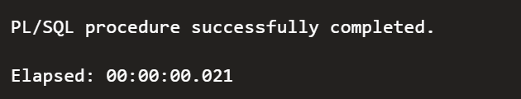
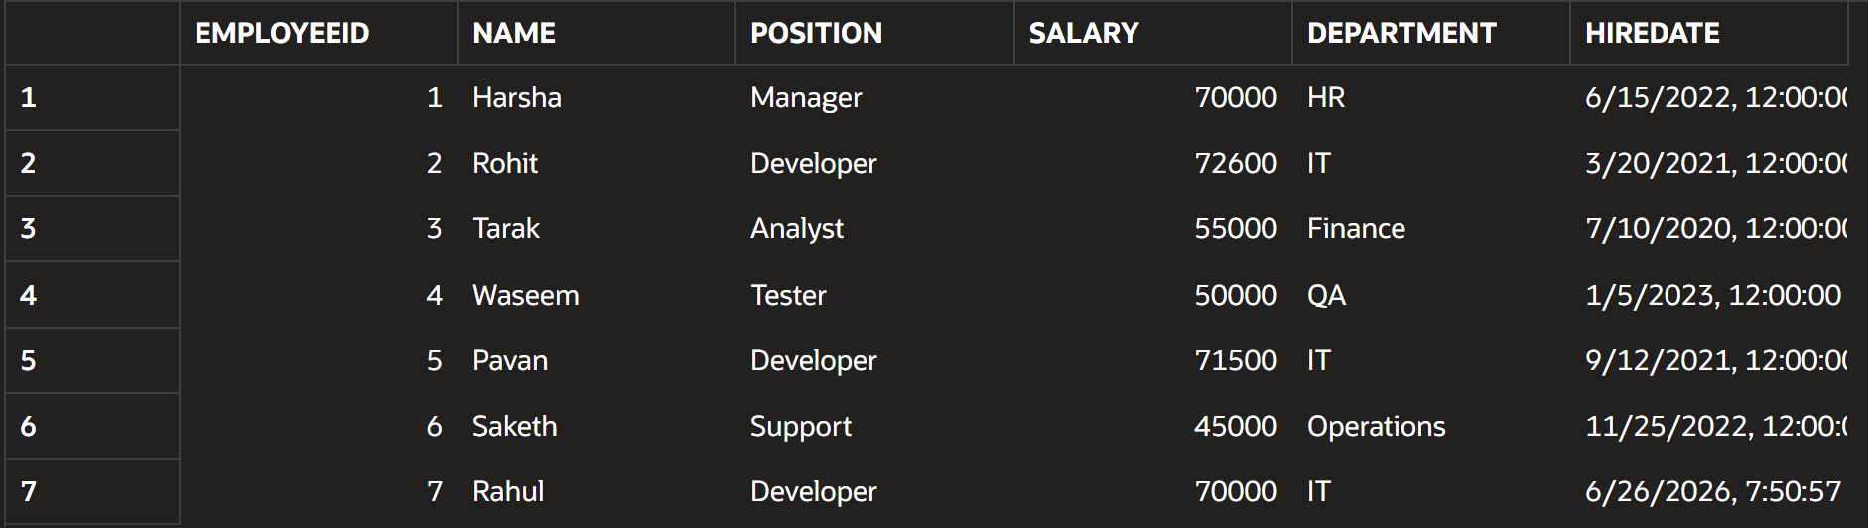

Scenario 3: Account Operations Package
Question:
Create a package AccountOperations that contains:
- A procedure to open a new account.
- A function to return the balance of an account.
Package Specification
CREATE OR REPLACE PACKAGE AccountOperations AS

PROCEDURE OpenAccount(
p_accid NUMBER,
p_custid NUMBER,
p_type VARCHAR2,
p_balance NUMBER
);

FUNCTION GetAccountBalance(
p_accid NUMBER
)
RETURN NUMBER;

END AccountOperations;
/
Package Body
CREATE OR REPLACE PACKAGE BODY AccountOperations AS

PROCEDURE OpenAccount(
p_accid NUMBER,
p_custid NUMBER,
p_type VARCHAR2,
p_balance NUMBER
)
IS
BEGIN
INSERT INTO Accounts
VALUES(
p_accid,
p_custid,
p_type,
p_balance,
SYSDATE
);
END OpenAccount;

FUNCTION GetAccountBalance(
p_accid NUMBER
)
RETURN NUMBER
IS
v_balance NUMBER;
BEGIN
SELECT Balance
INTO v_balance
FROM Accounts
WHERE AccountID = p_accid;

RETURN v_balance;
END GetAccountBalance;

END AccountOperations;
/
Execution
BEGIN
AccountOperations.OpenAccount(
7,
1,
'Savings',
25000
);
END;
/

SELECT AccountOperations.GetAccountBalance(7)
AS Balance
FROM DUAL;

